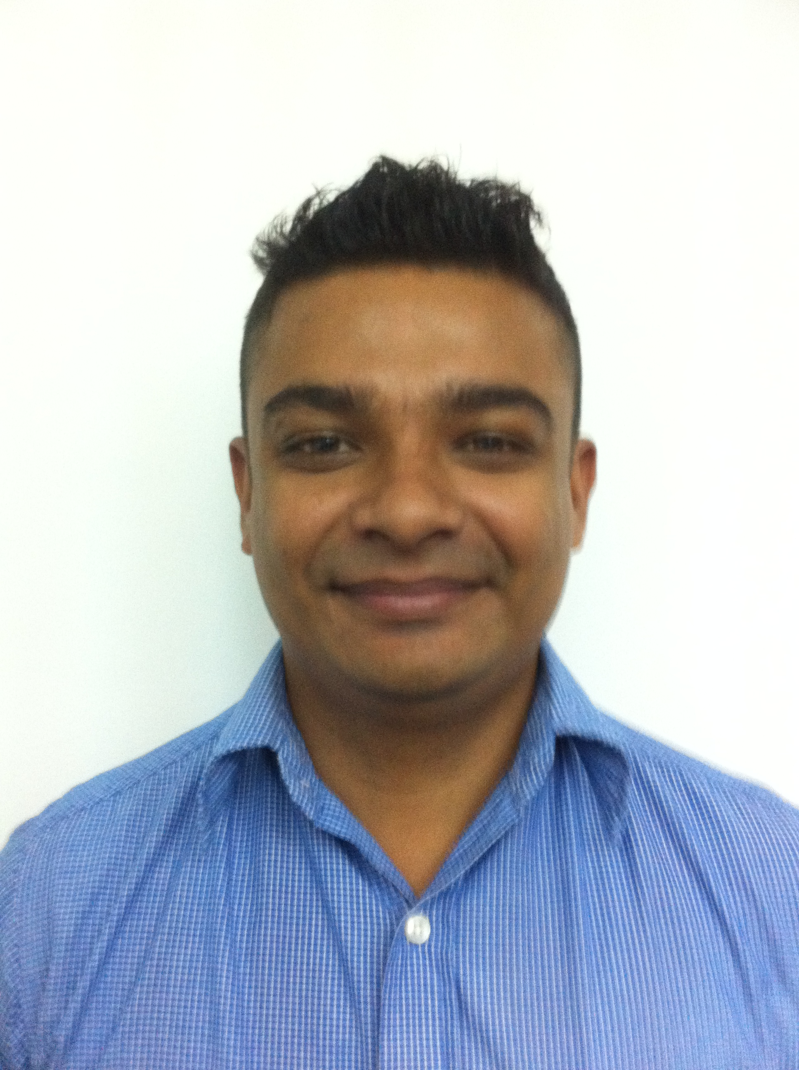
ANDERIO FREDRICK TOUSSAINT
168 / 1B, Stanley Thilakarathna Mawatha,
Nugegoda, Sri Lanka.
Mobile: +94 777 334105
Email: anderio21@gmail.com

Areas of Expertise
- Team Leadership / Motivation
- CRM
- Staff Supervision / Development
- New Promotions
- Problem Solving
- Quality Assurance

Professional Experience

Mr. Cricket - Retail Manager (January 2014 to up to date)
My responsibilities include:
- Meeting school cricket coaches and other relevant cricket instructors to promote the shop’s products.
- Visiting suppliers for quality checking, bargaining prices and placing stock orders.
- Handling walk-in customers in terms of offering advice, assisting in the product selection process based on individual requirements and promoting new arrivals.
- Researching on latest product arrivals and current trends in the market to ensure being up-to-date in the field.
- Coordinating the social media of the shop.
- Identifying customer wants and needs and ensuring supply or provision of alternatives.
- Creating of quotations for clients.
- Handling daily sales and cash flow.
- Other general operations of running a shop, i.e. ensuring stock levels are maintained, handling petty cash, providing guidance to assistant, producing sales reports, etc.

Mediawize - Senior Client Serving Executive (January 2013 to up to December 2013)
My responsibilities included:
- Looking into clients’ needs and requirements and serving them to their expectations.
- Ensuring deadlines are met as given by the client and the management.
- Coordinating all the advertising activities/websites/printing of promotional material with the suppliers and working accordingly.
- Identifying customer queries and providing resolutions.
- Promoting and marketing the company as an advertising and marketing solution provider.

D.C. I Recruitments (Private) Limited (August 2011 to up to December 2012)
Consultant - My responsibilities included:
- New business generation – making canvass calls and carrying out mail shot activities.
- Meeting sales/gross profit targets in line with dashboard.
- Dealing with speculative calls, aftercare and service calls.
- Client visits – new and service – as well as identifying and following up on business leads.
- Creating proposal documents and tenders, negotiating fees and rates in line with company policy considering approvals and discounts allowed and issuing terms of business documentation.
- Write and place advertisements in newspapers and on website and keep in contact with job canters and colleges.

Client management - My responsibilities included:
- Serving clients, identifying their needs and providing feedback on success of filling jobs.
- Qualifying job specification / salary information and recording accurate and comprehensive job descriptions – checking information / client requirements in line with key processes and legislation.
- Gather information on clients – key decision maker, required numbers of employees, etc.
- Network internally and externally with clients.
- Benchmarking for clients – salary, availability, candidate pool, industry activity.
- Writing and placing advertisements in newspapers and on websites.

Candidate management - My responsibilities included:
- Candidate control – maintaining regular contact to review progress and performance.
- Pre-screening candidates before their interviews to check their suitability.
- Conducting interviews with suitable candidates.
- Coaching candidates on facing interviews in terms of required interview skills/skills testing.
- Handling CVs: Speculating CVs/marketing candidates, searching/short listing CVs in line with the job order request, ensuring CVs are of required standards and reflective of client request.
- Providing information to candidates on clients and job specifications for permanent jobs.

Dialog Axiata PLC - Key Client Hospitality Service Officer (November 2005 up to February 2011)

My responsibilities included exceptional service to the Club Vision High End customers on queries and ensuring the requested services are provided within the specified time frame by maintaining proper service standards in order to exceed customer expectations.

In greater detail,

My responsibilities included:
- Handling loyalty programmes for the High End Customer base
- Constantly maintain and exceeding customer satisfaction.
- Monitoring customer communication and retention.
- Monitoring agent’s daily flow and maximized customer satisfaction effectively.
- Identifying customer queries and providing resolutions.
- Responsible for overlooking and achieving allocated target of the team visits of the division

Power House Advertising - Production Coordinator (2001 up to 2003)
My responsibilities included:
- Analysing promotional information on advertising
- Handling promotional documentation
- Finalising locations for the commercials

Extracurricular Activities and Significant Achievements

- A member of the school prefect guild from 2001 to 2002.
- Member of the school cricket team from 1992 to 1996 as an all-rounder.
- Captained the U13 cricket team for 2 consecutive years from 1995 to 1996.
- Held the positions of wicket keeper and opening batsman for U15 & U17 from 1996 to 1998.
- Received Collage Colours Award for 47 victims behind the wickets and 471 runs for the year 2000 to 2001.
- Received Collage Colours Award for 35 victims behind the wickets and 739 runs for the year 2001 to 2002.
- Participated for Lemonade Limited Overs’ Trophy in 2002.
- Held the position of the Most Popular School Boy All Island Cricketer of the year 2001 / 2002.
- A member of the school soccer team (Under 12, 14, 16).
- Vice captained the school soccer team U16 and the Colombo Schools Runners up team in 1999.
- Captained the school soccer team U18 in 2002.
- Received awards for College Colours in years 1999 / 2000 - 2002 / 2003.
- Held the position of Wesley College Sportsman of the year 2000 / 2001.
- Represented NCC U-23 First XI & Division II Captain.
- Played cricket in New Zealand 2003 Season – Celtic Cricket Club Division I (as a wicket keeper and a batsman).
- Played cricket in New Zealand 2003 Season – Blenheim District Side Division I (as a wicket keeper and a batsman).
- Played mercantile cricket for Dialog Axiata PLC (2005 – 2011).
- Captained the Dialog cricket team for the 2010 mercantile cricket season.

Academic Qualifications: G.C.E. Ordinary Level Examination – 1999

- English Language Distinction
- Sinhala Language Credit Pass
- Social Studies Credit Pass
- Science I Credit Pass
- Science II Credit Pass
- Mathematics I Credit Pass
- Mathematics II Simple Pass
- Religion Simple Pass

Personal Details

- Full Name : Anderio Fredrick Toussaint
- Postal Address : 168 / 1B, Stanley Thilakarathna Mawatha, Nugegoda, Sri Lanka.
- Contact Phone No. : +94 0777 334 105
- E mail : anderio21@gmail.com
- Date of Birth & Age : 27th July 1983 - 32 years
- Nationality : Sri Lankan
- National Identity Card : 832091014 V
- Pass Port Number : N3045051
- School Attended : Wesley College (Colombo 08)

Names and address of non-related referees

- Mr. Farveez Maharoof (Sri Lankan Cricketer) - Assistant Manager
MAS Intimates (Cooperate Communication)
Borupana Road,
Ratmalana,
Sri Lanka.
Mobile: +94 0773 011 522

- Mr. Suren Candappa - Business Development Manager
Scan Distribution Center Lanka (Pvt) Ltd.
No. 67/1, Hudson Road,
Colombo 03,
Sri Lanka.
Mobile: +94 071 4 286 231
Tel: +94 011 2 426 660 (Ext: 450)

I do hereby certify that the above facts furnished by me are true and correct to the best of my knowledge.

........................................... ..............................
Anderio F Toussaint Date

